**AWS FINAL EXAM DOCUMENTATION**

**Nodejs installation**

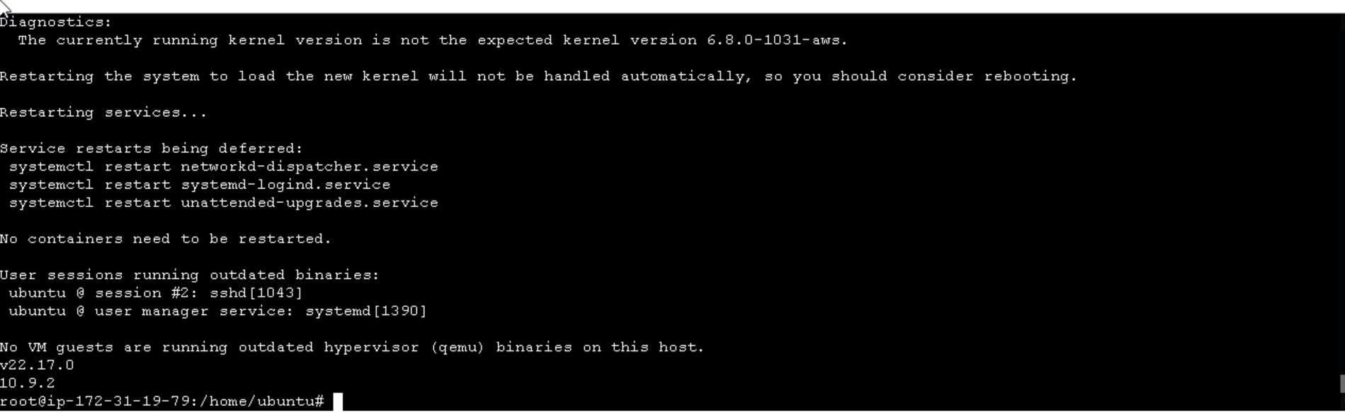

**ECR Repository Creation**

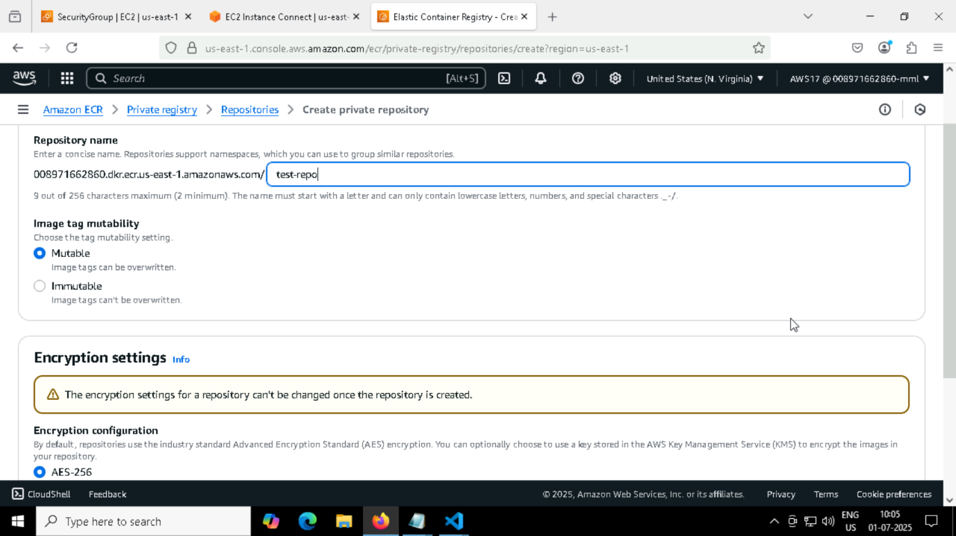

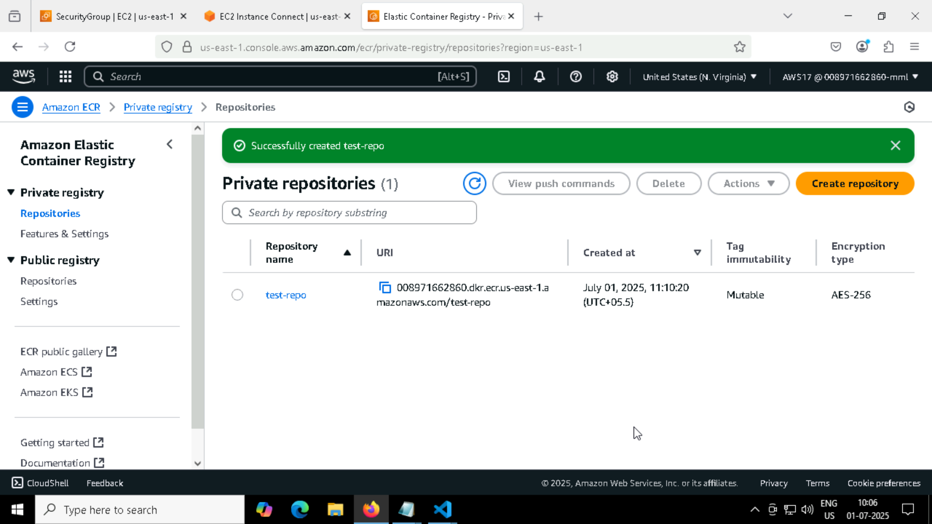

**2.Creating of EKS Cluster with worker node**

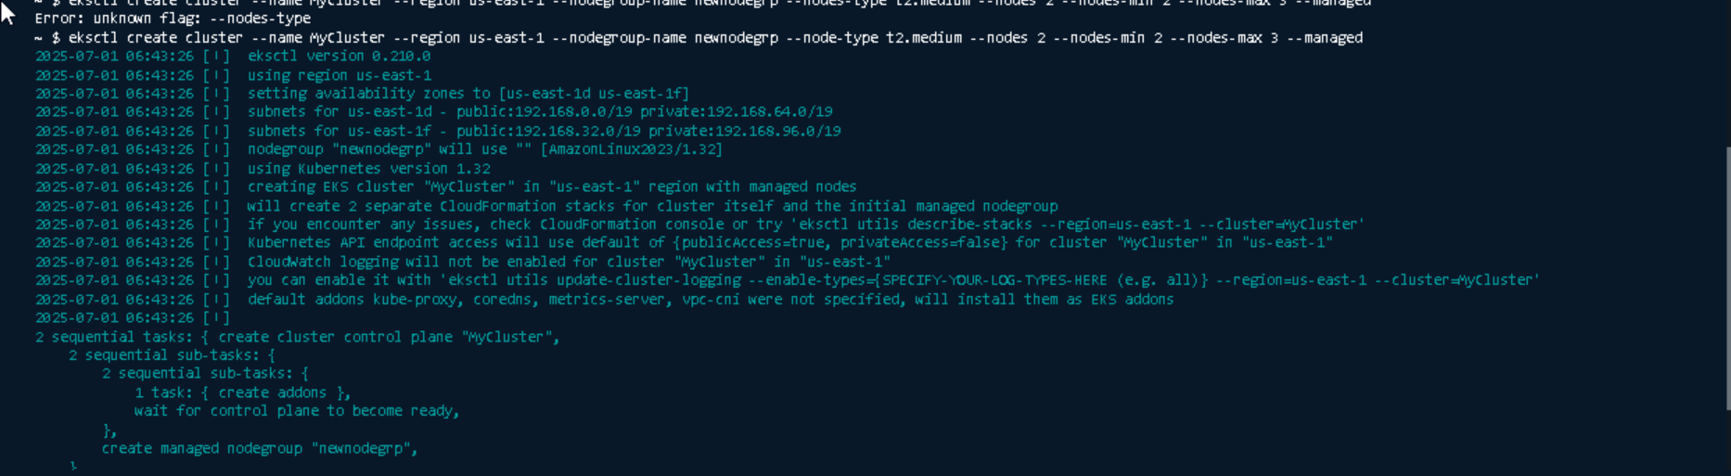

**EKS cluster is in Ready State:**

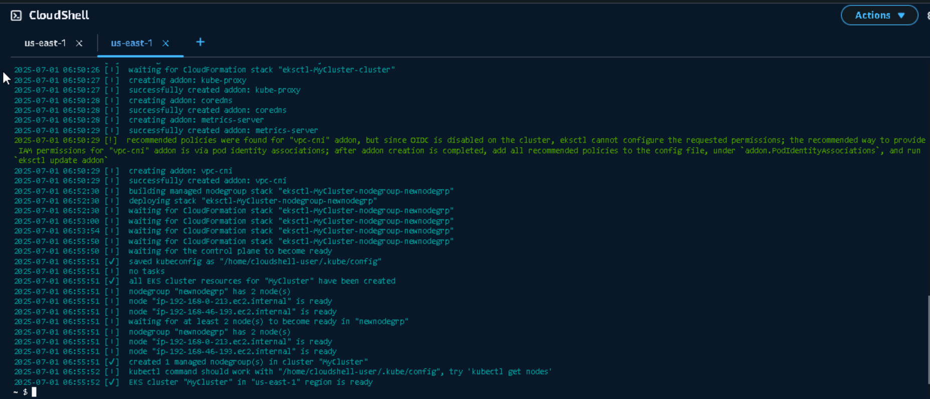

**Verifying cluster and worker nodes using cli commands and also with Console**

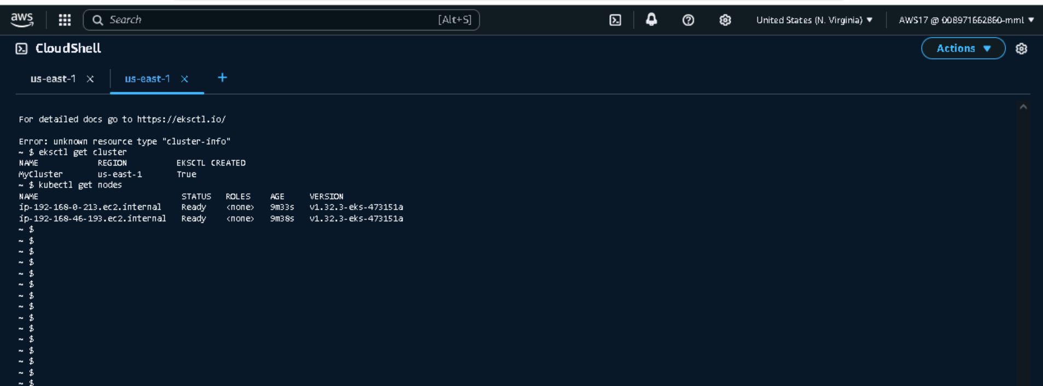

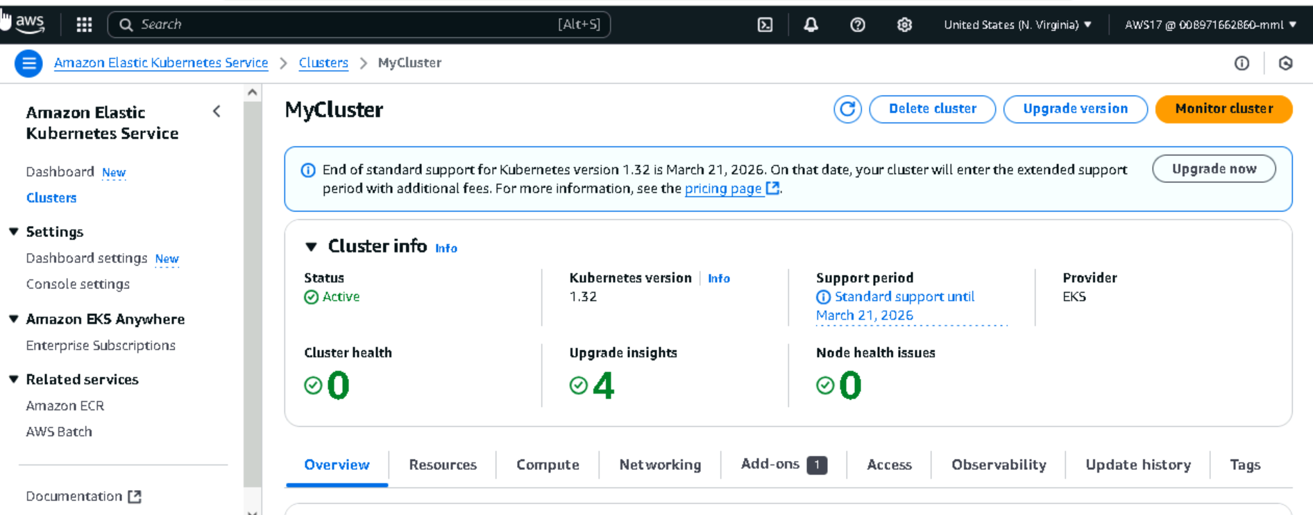

**Nodegroup and Nodes**

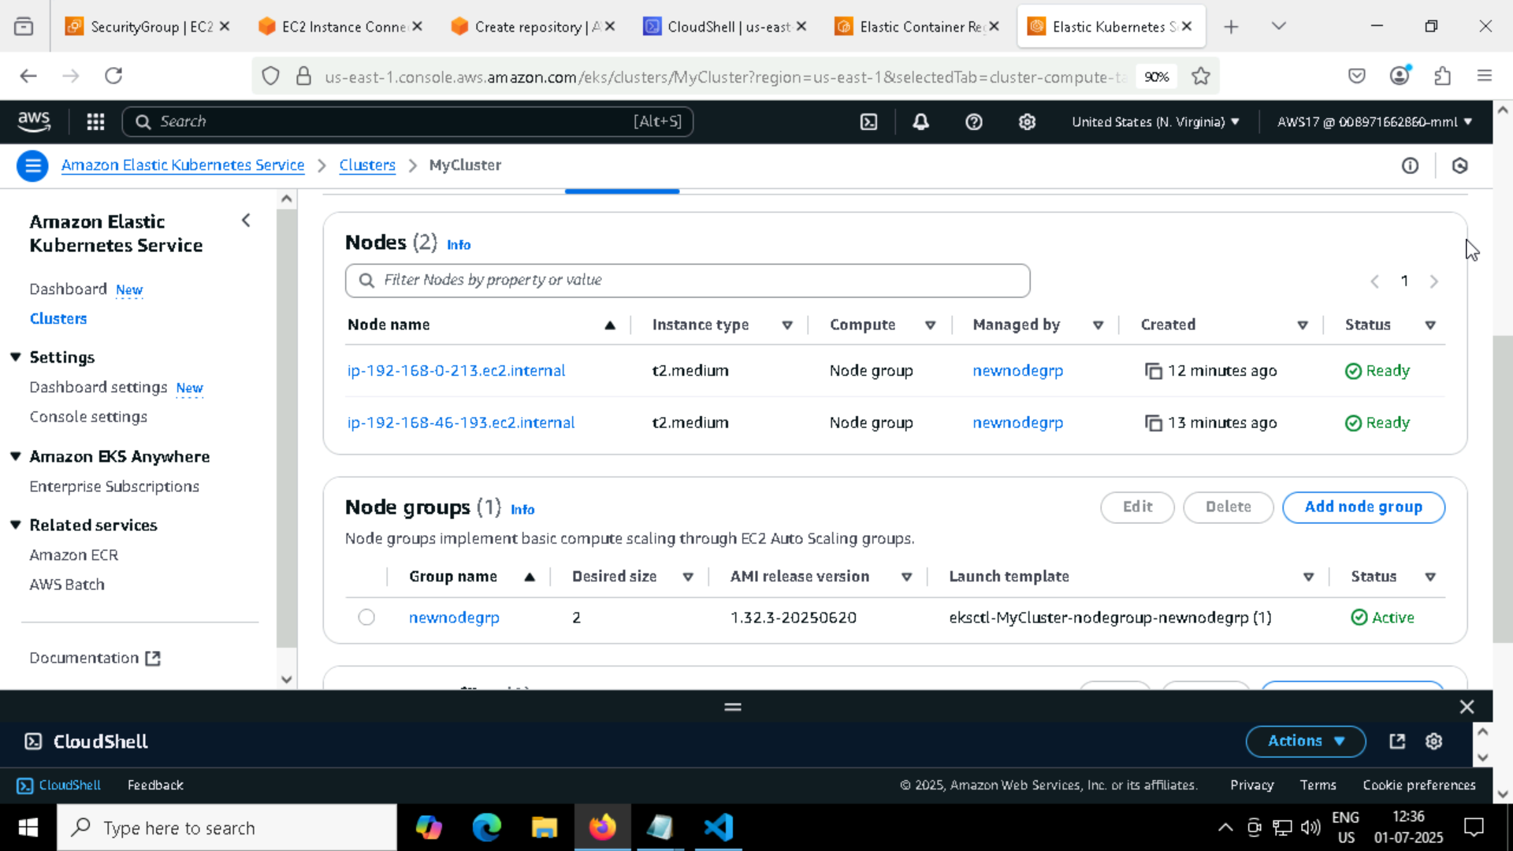

**Creating code commit repo**

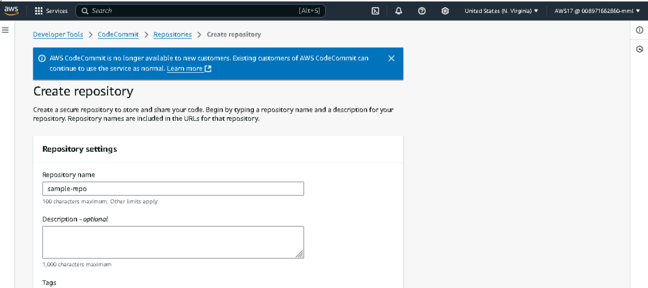

**Cloning the repo using git clone command in Aws cli**

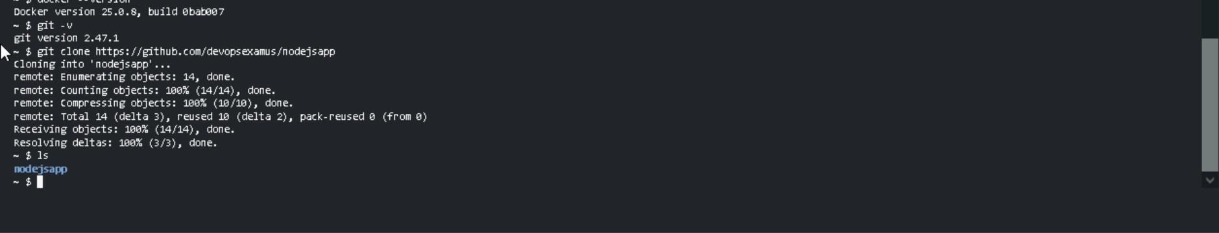

**Pushing all the file into Codecommit**

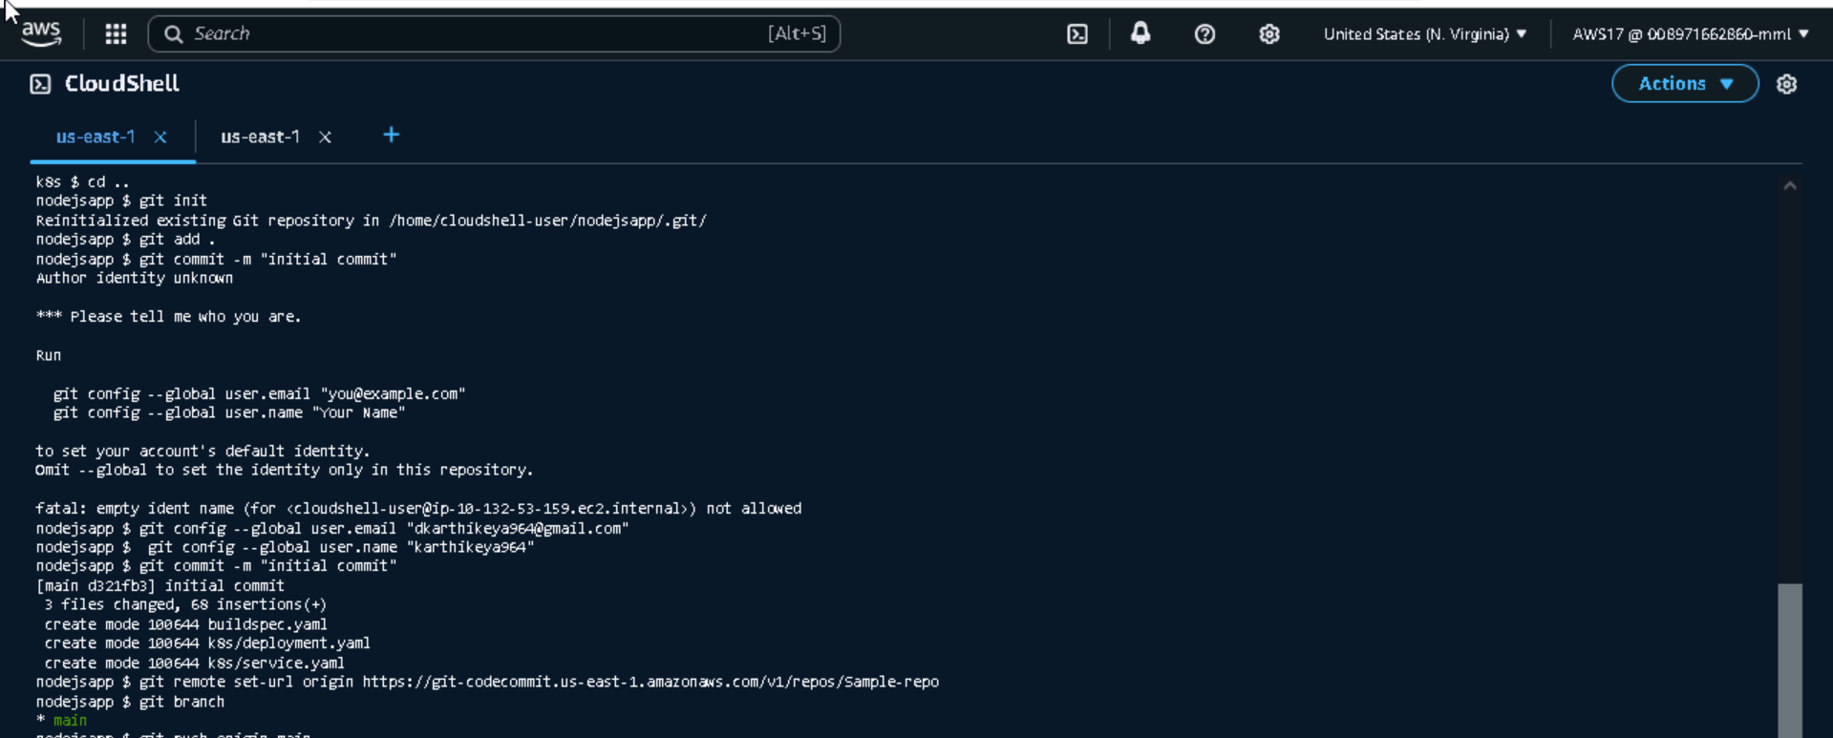

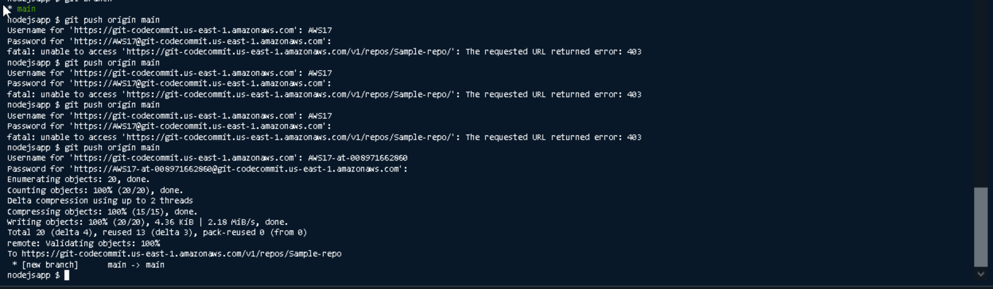

**Codecommit repo:**

**All my files are inside the sample-repo**

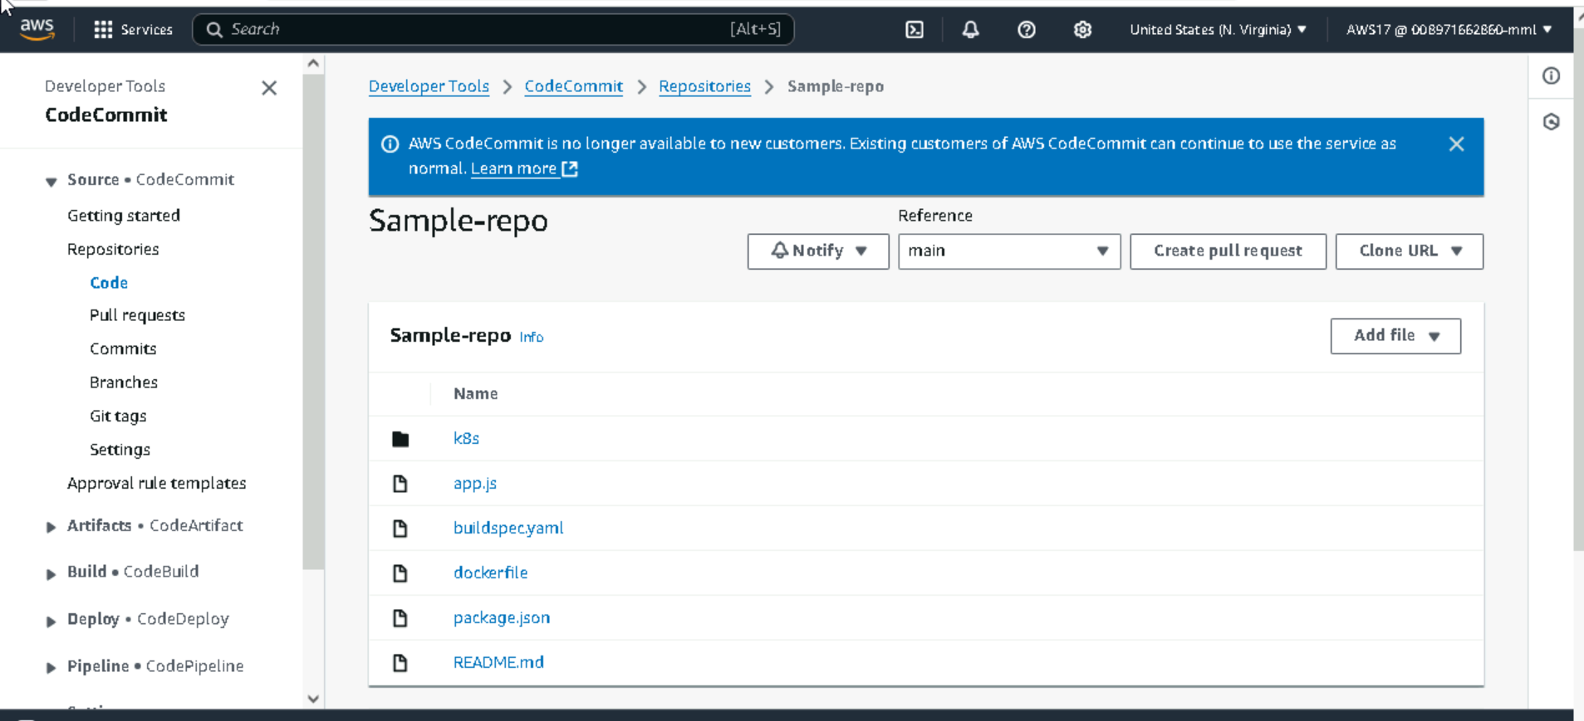

**Buildspec.yml**

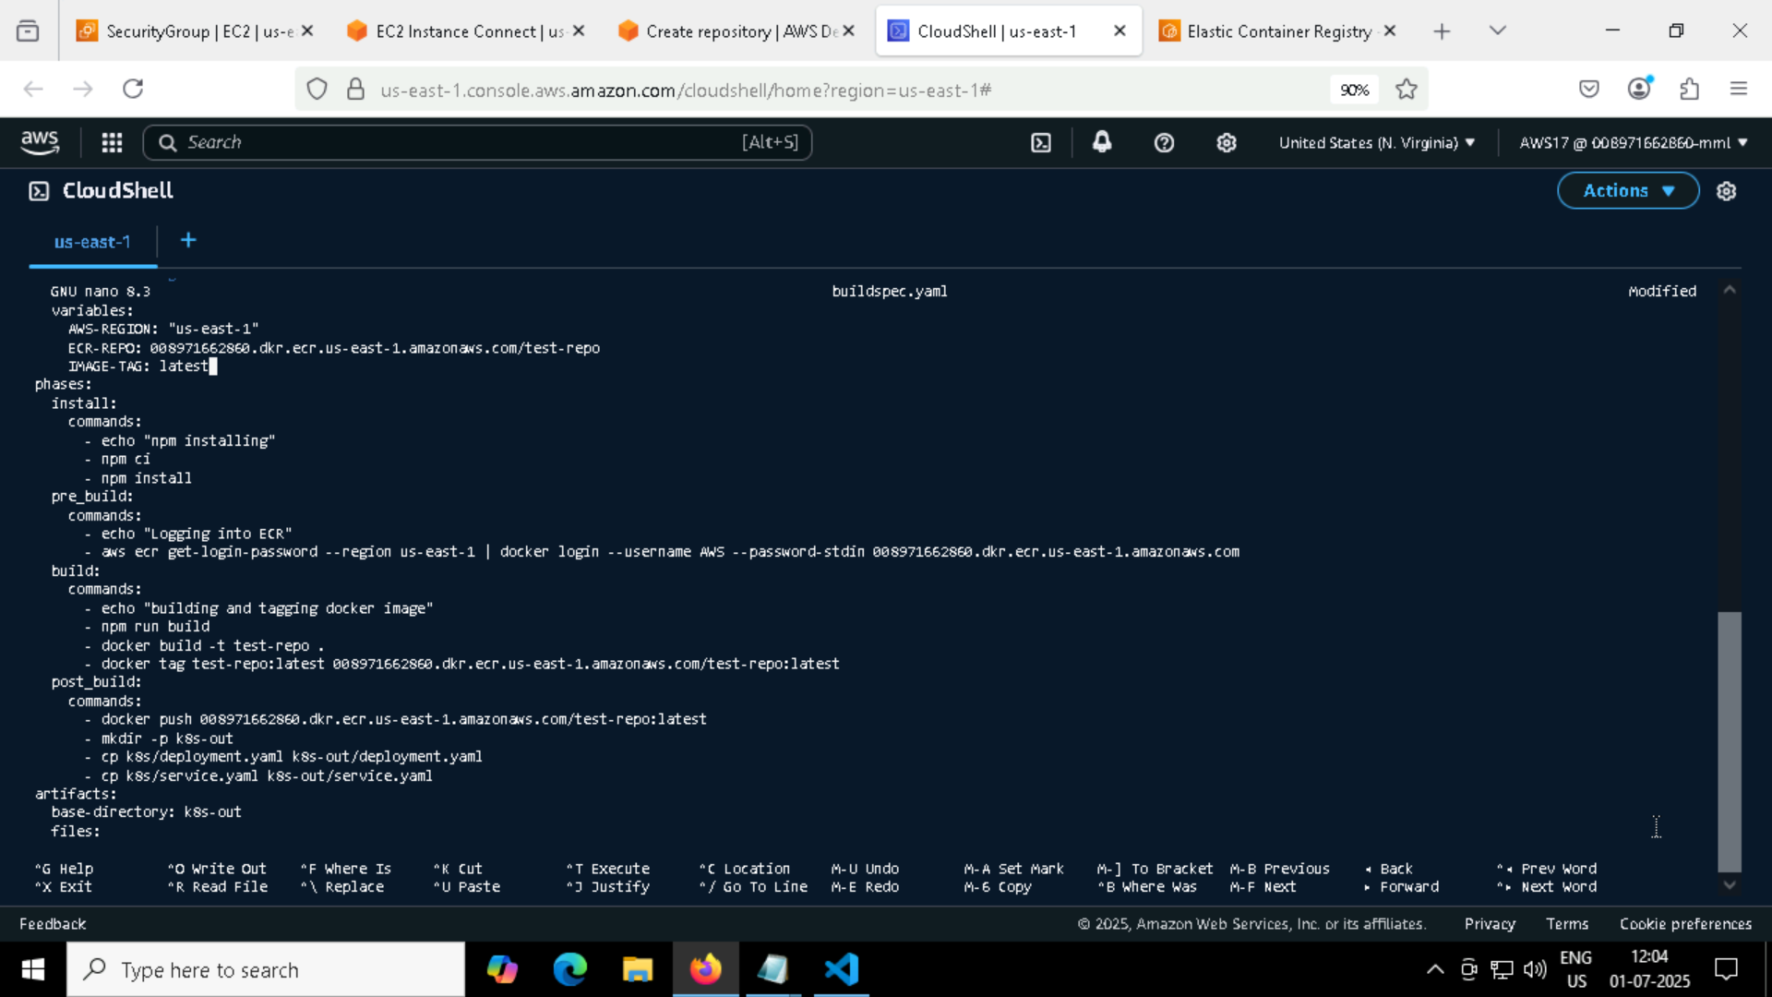

**Buildspec yaml through codecommit**

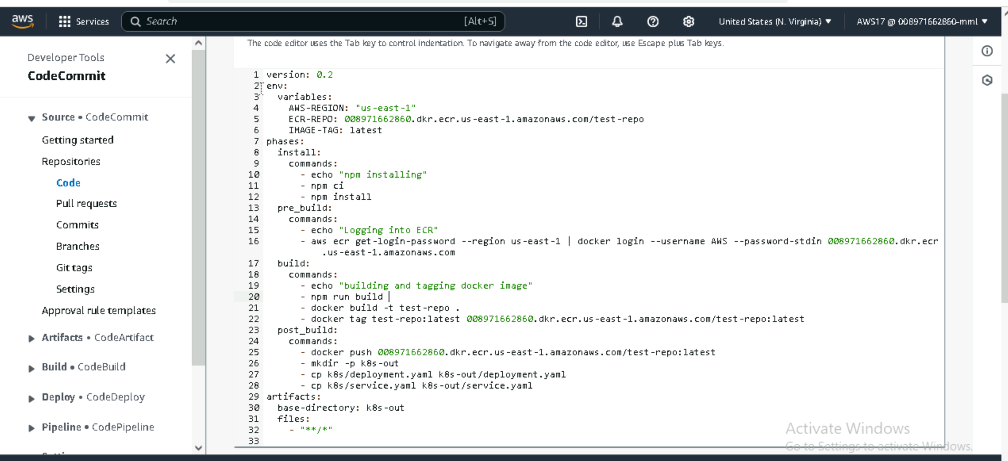

**Deployment.yaml :**

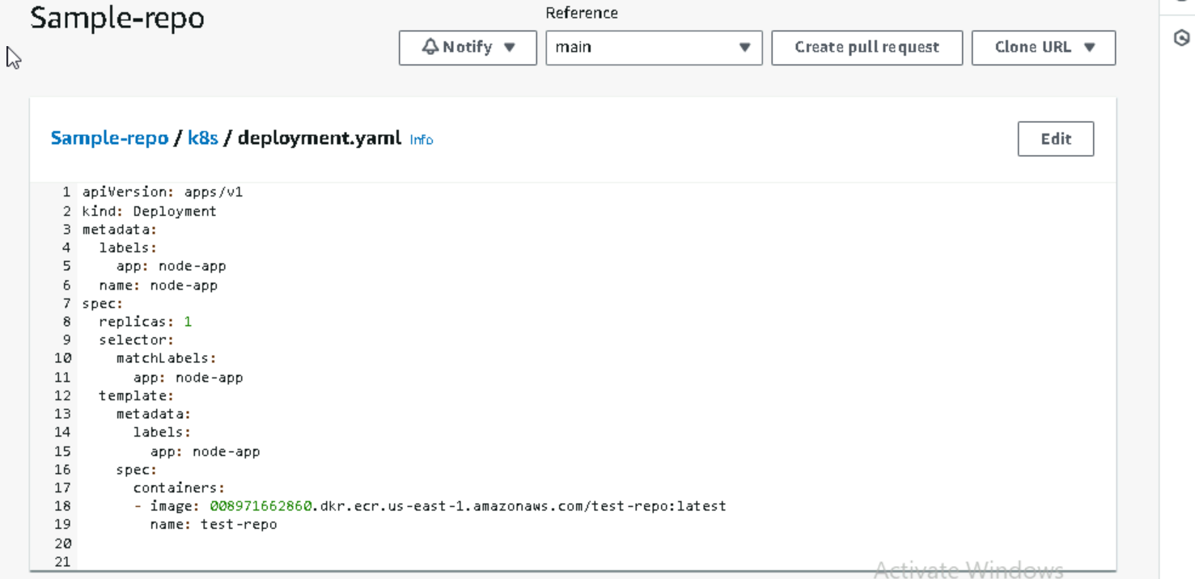

**Service.yaml**

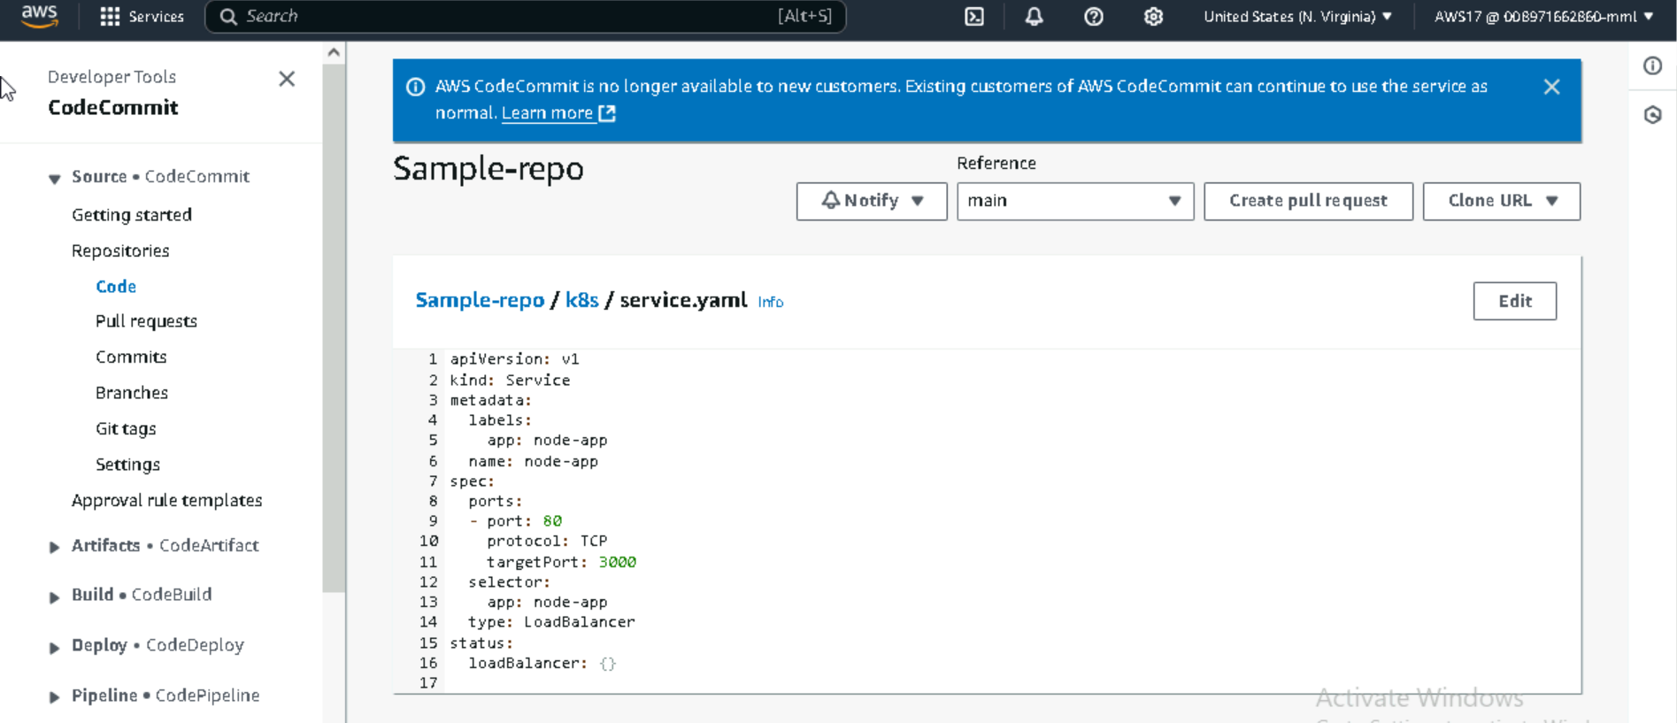

**CODE BUILD:**

**Build succeed**

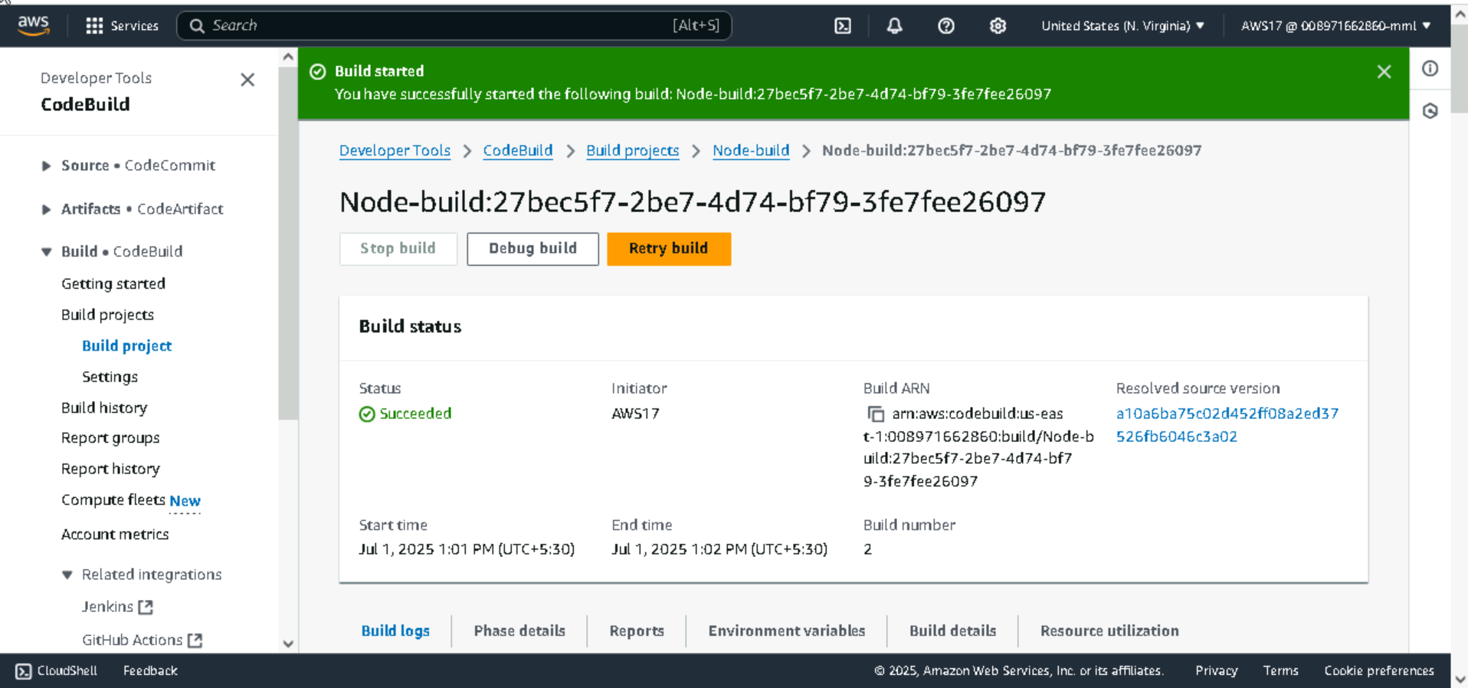

**Source I have taken from AwsCode Commit service in codebuild**

**Build logs:**

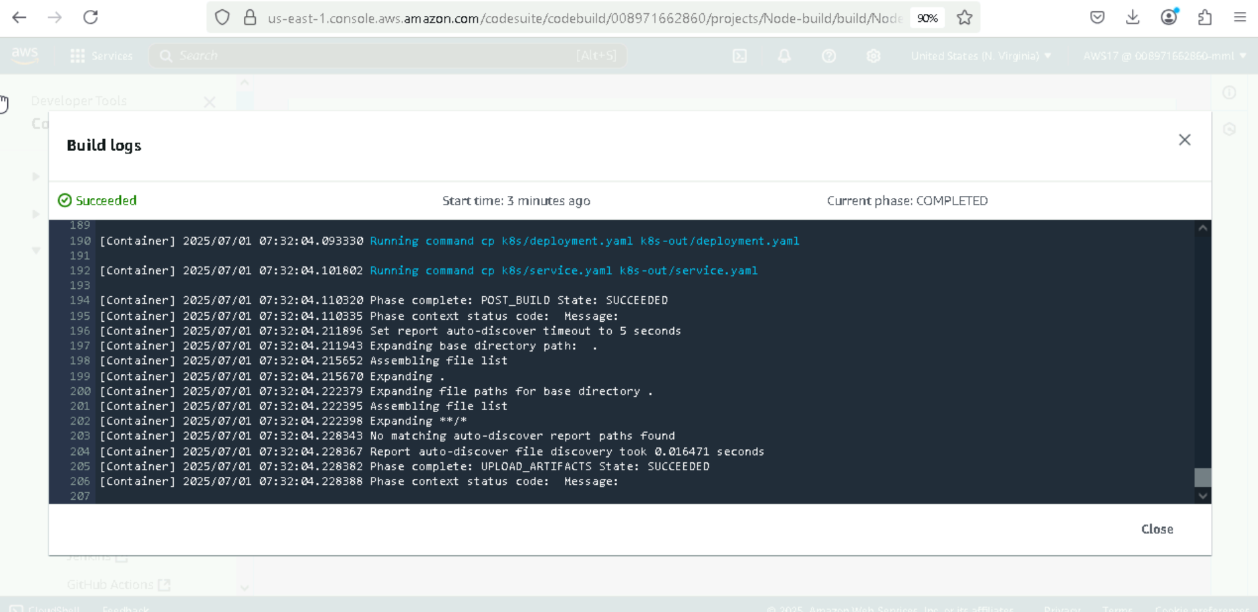

**Image is pushed in ECR repo**

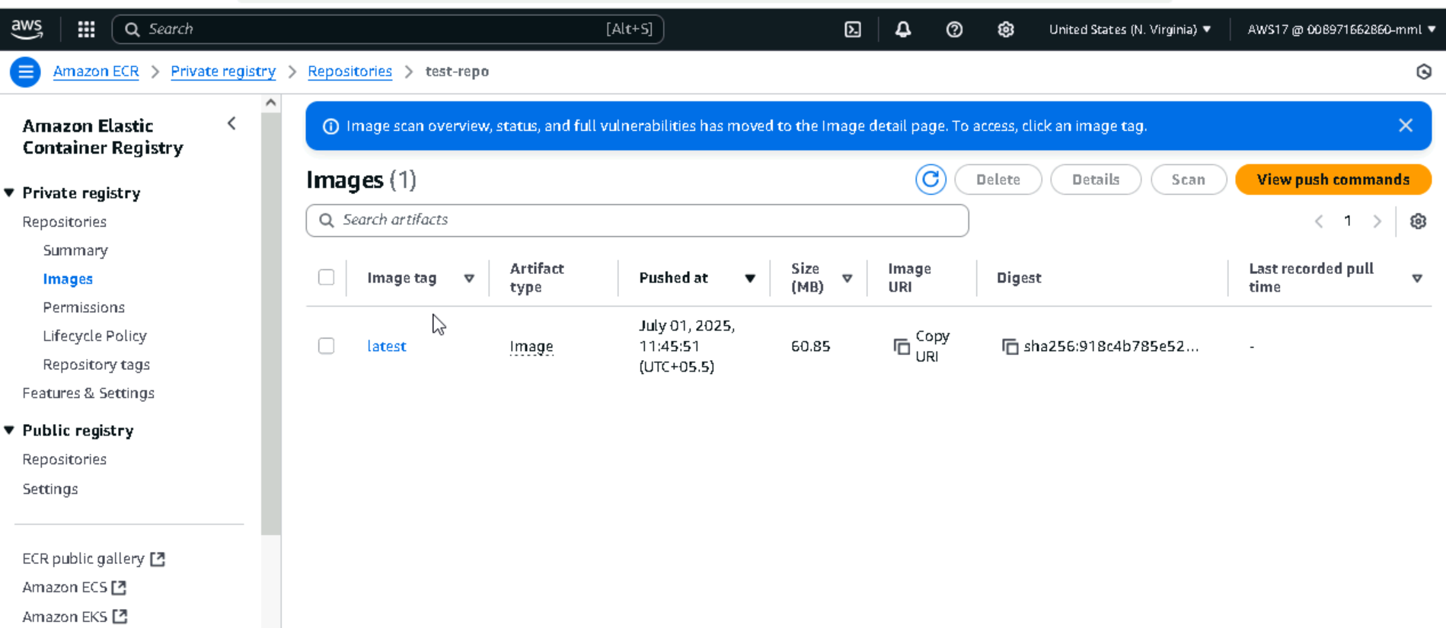

**Node pipline Creation:**

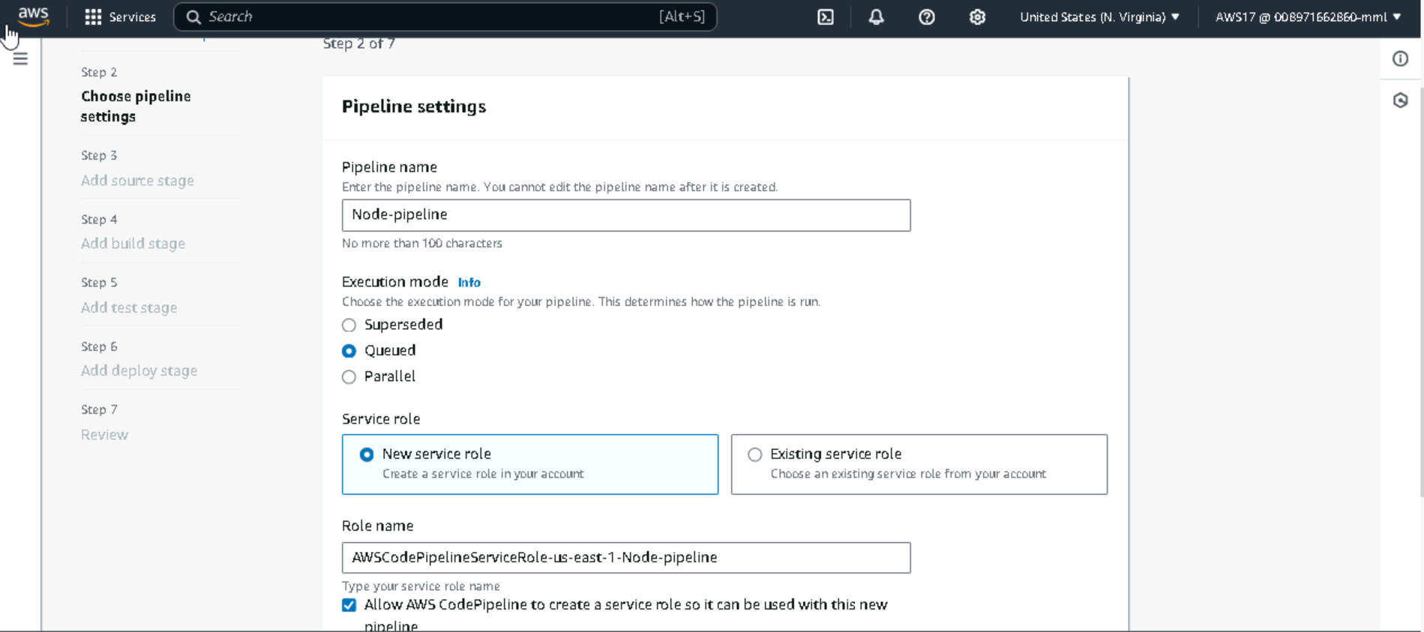

**Source : Aws codecommit**

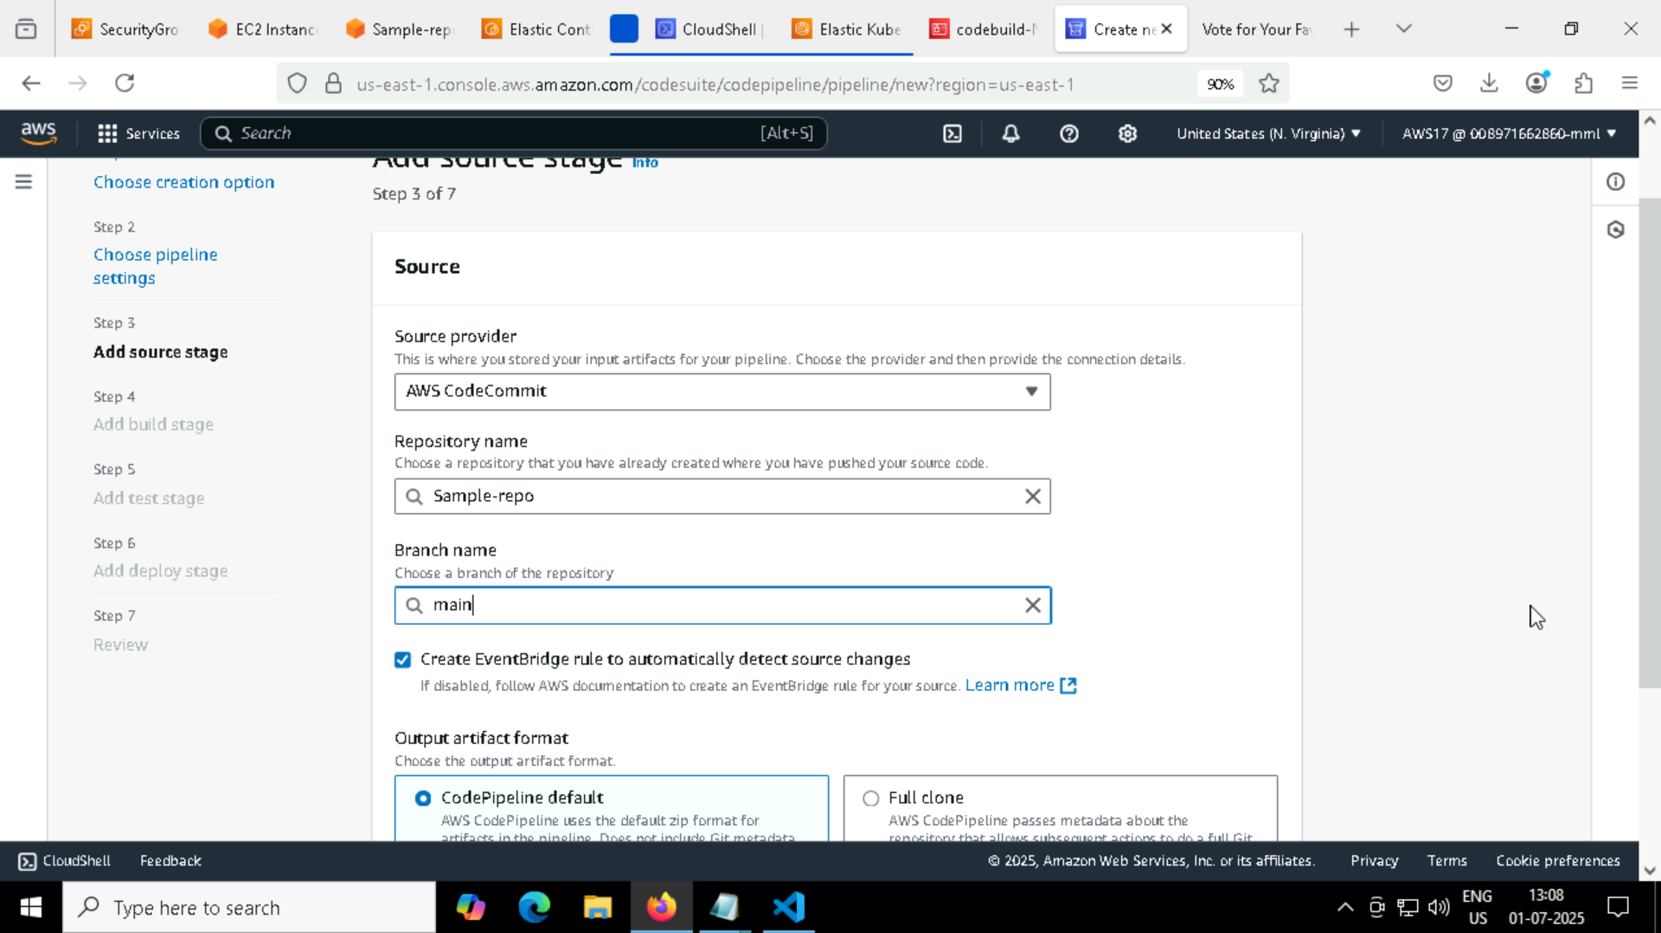

**Giving Codebuild for pipline**

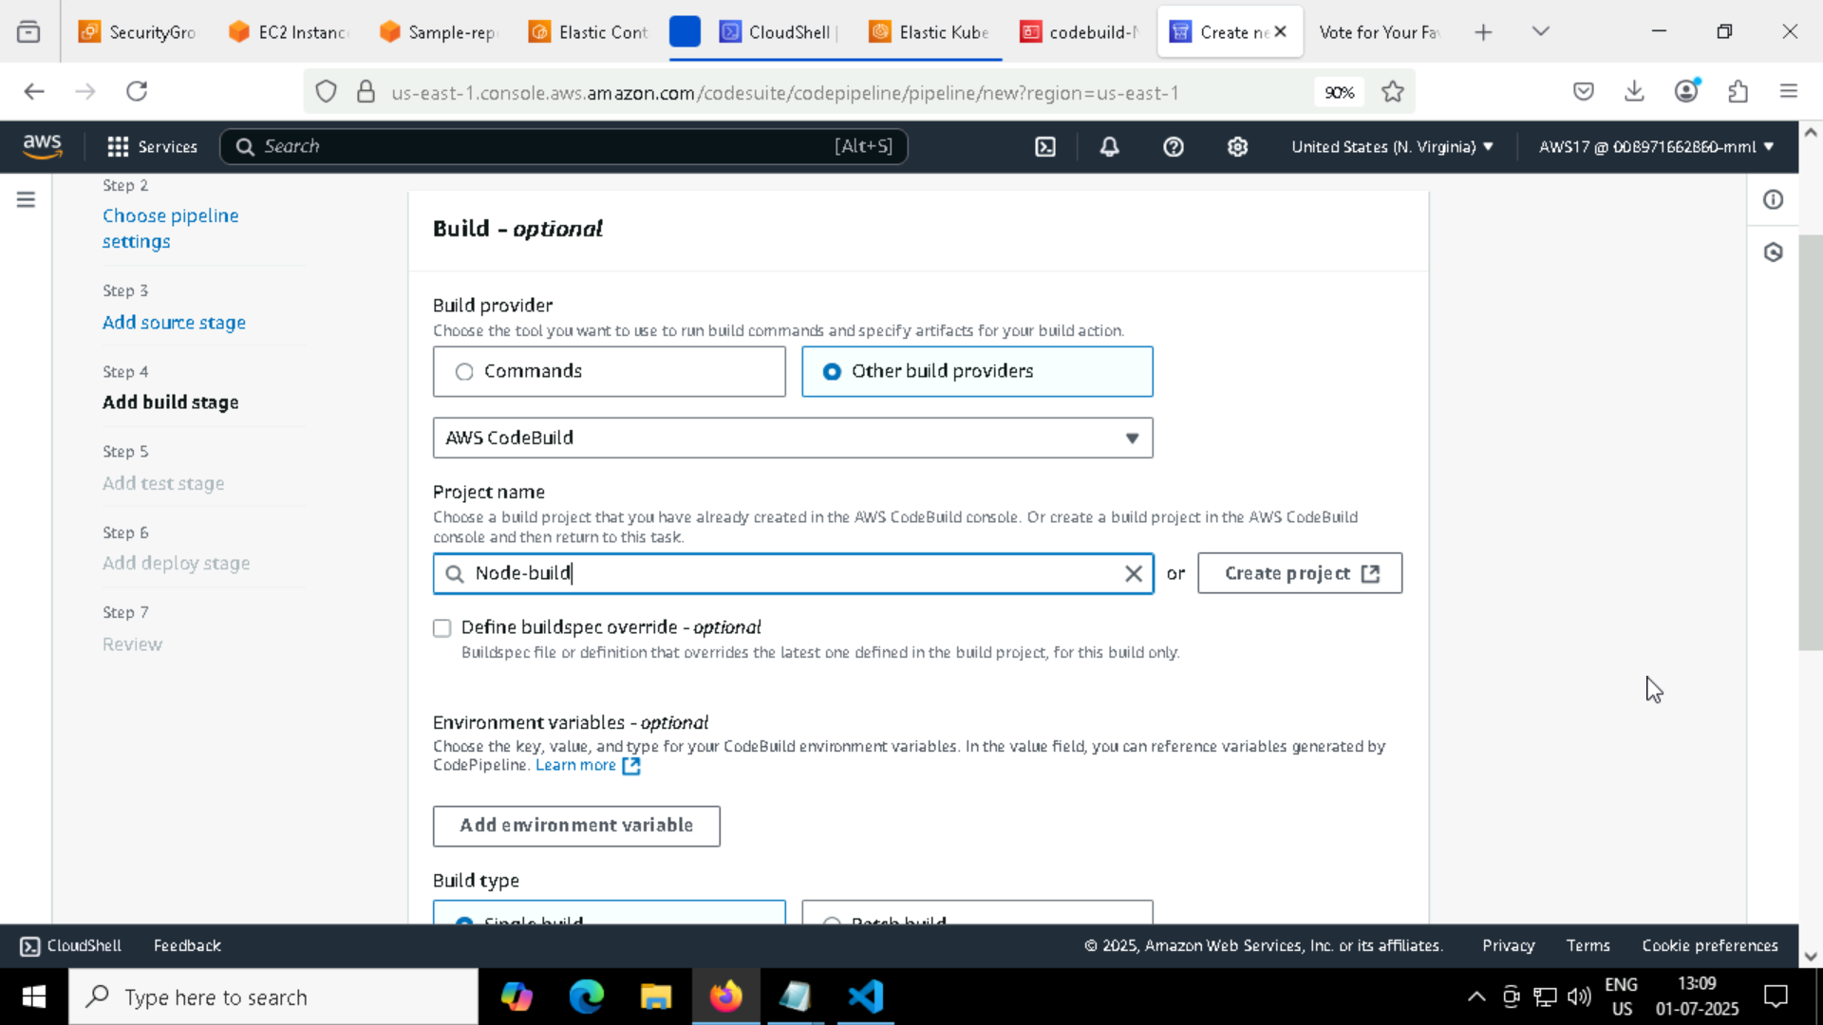

**Deploying in EKS cluster in codepipeline**

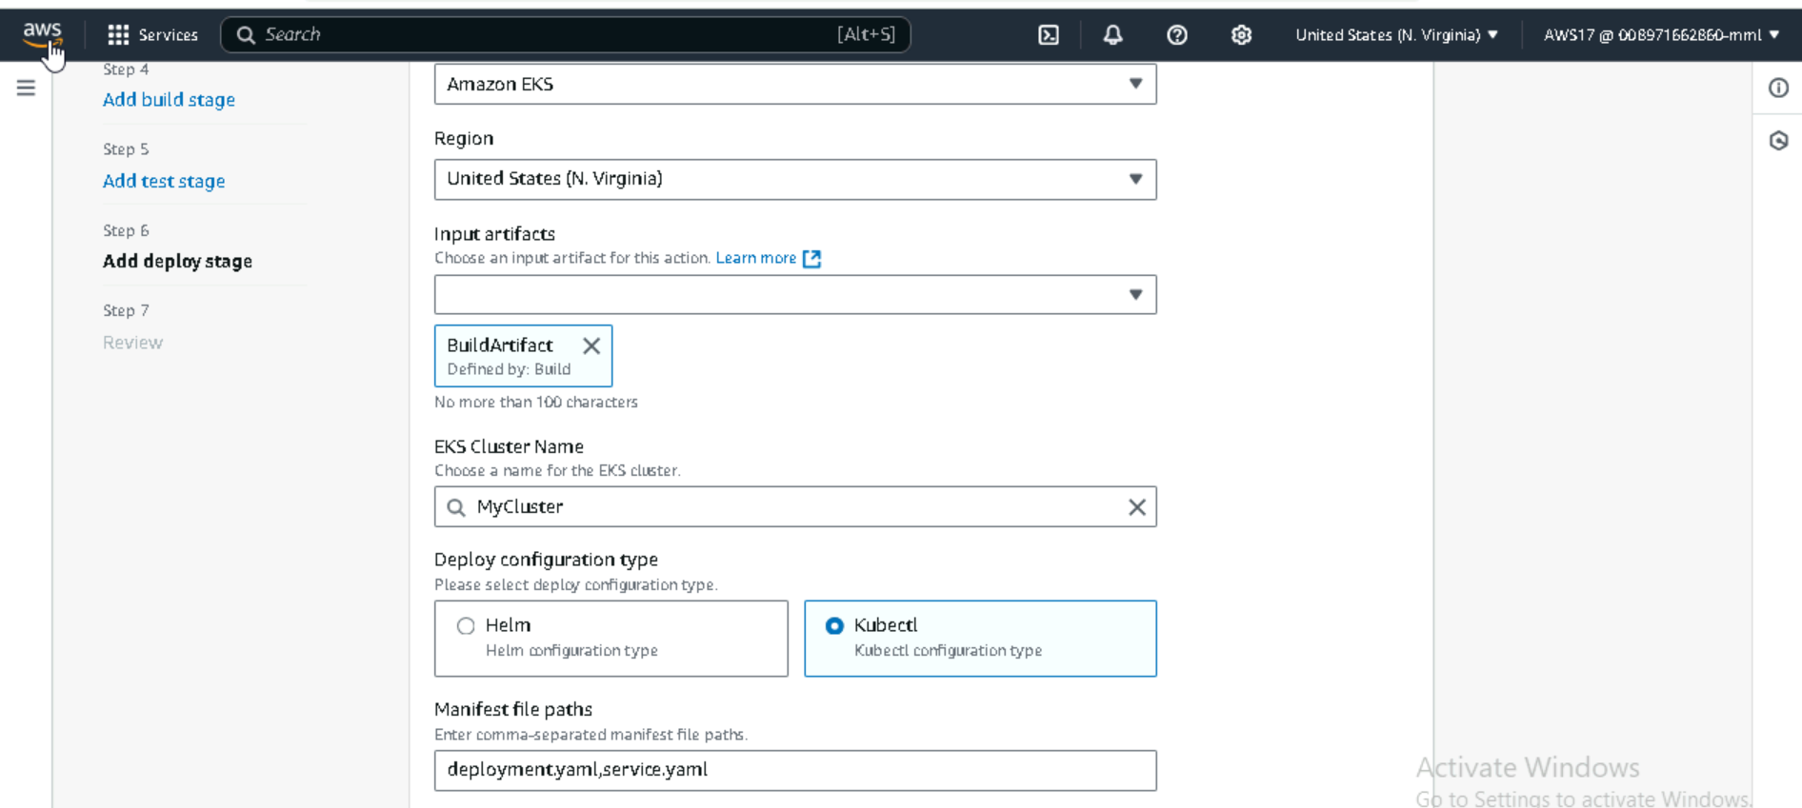

**Giving EKS Cluster Service Role of Our Node-pipeline**

**Kubernetes Service Connection:**

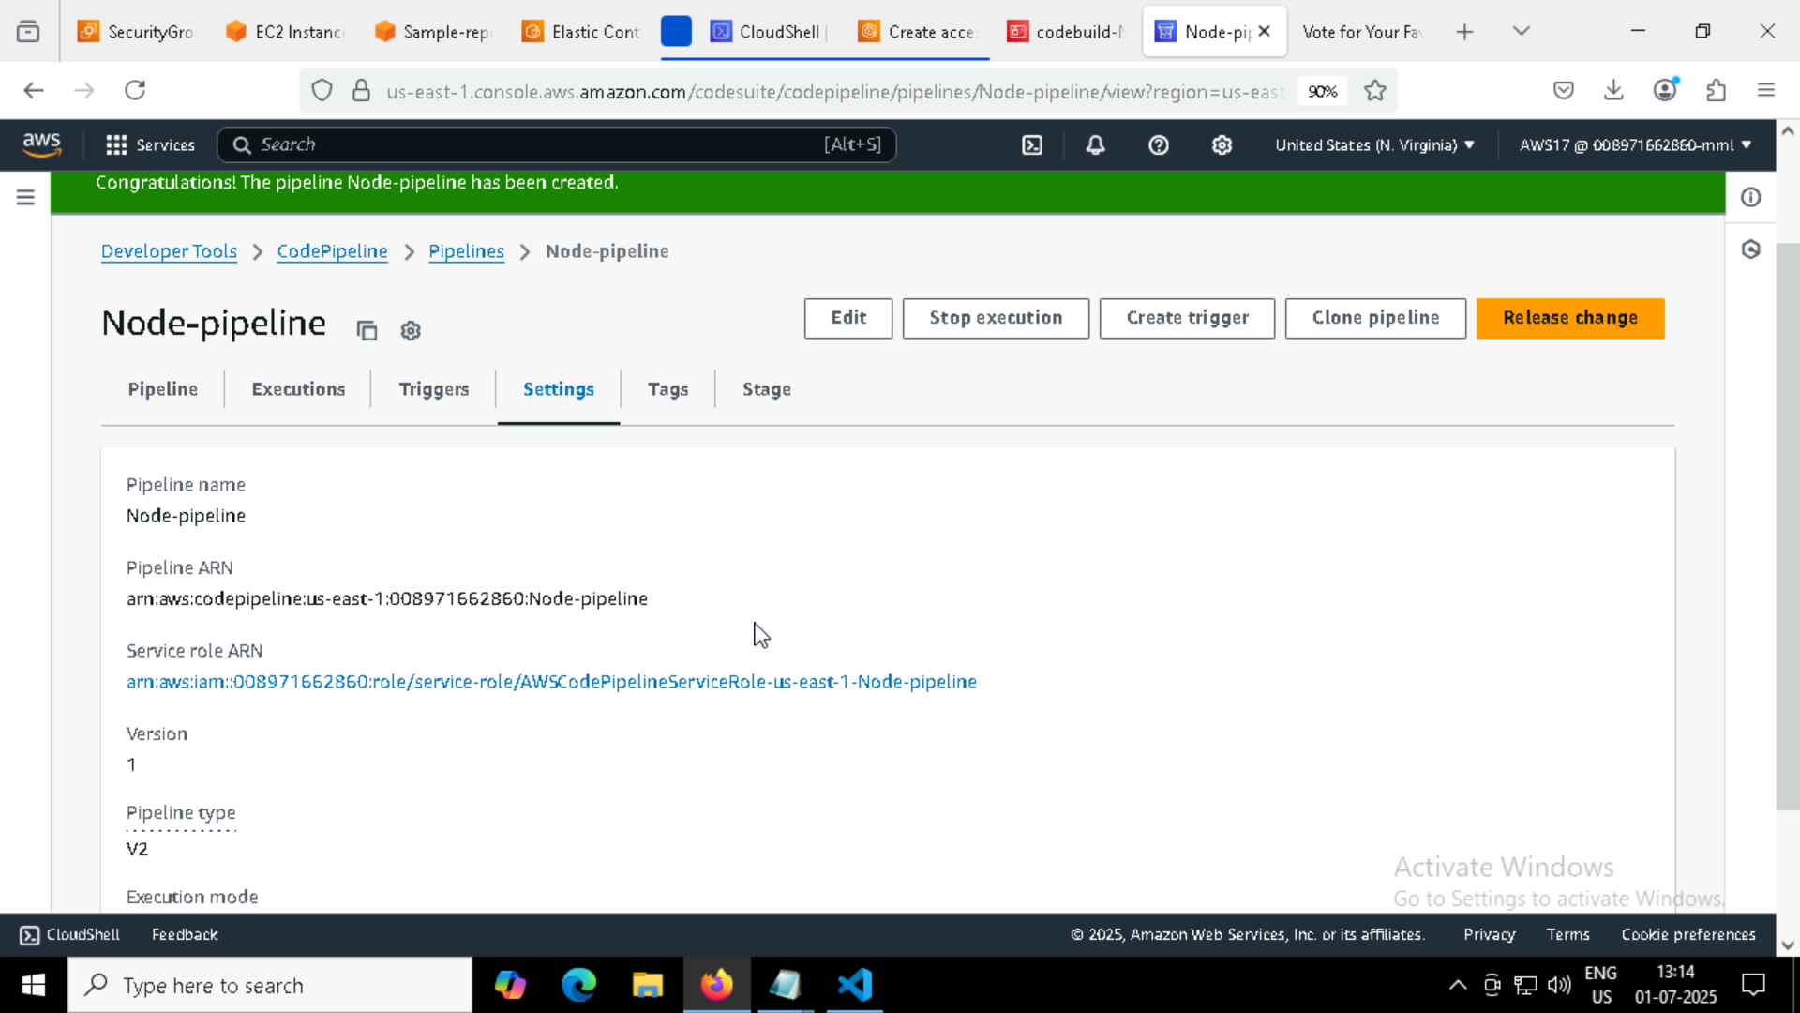

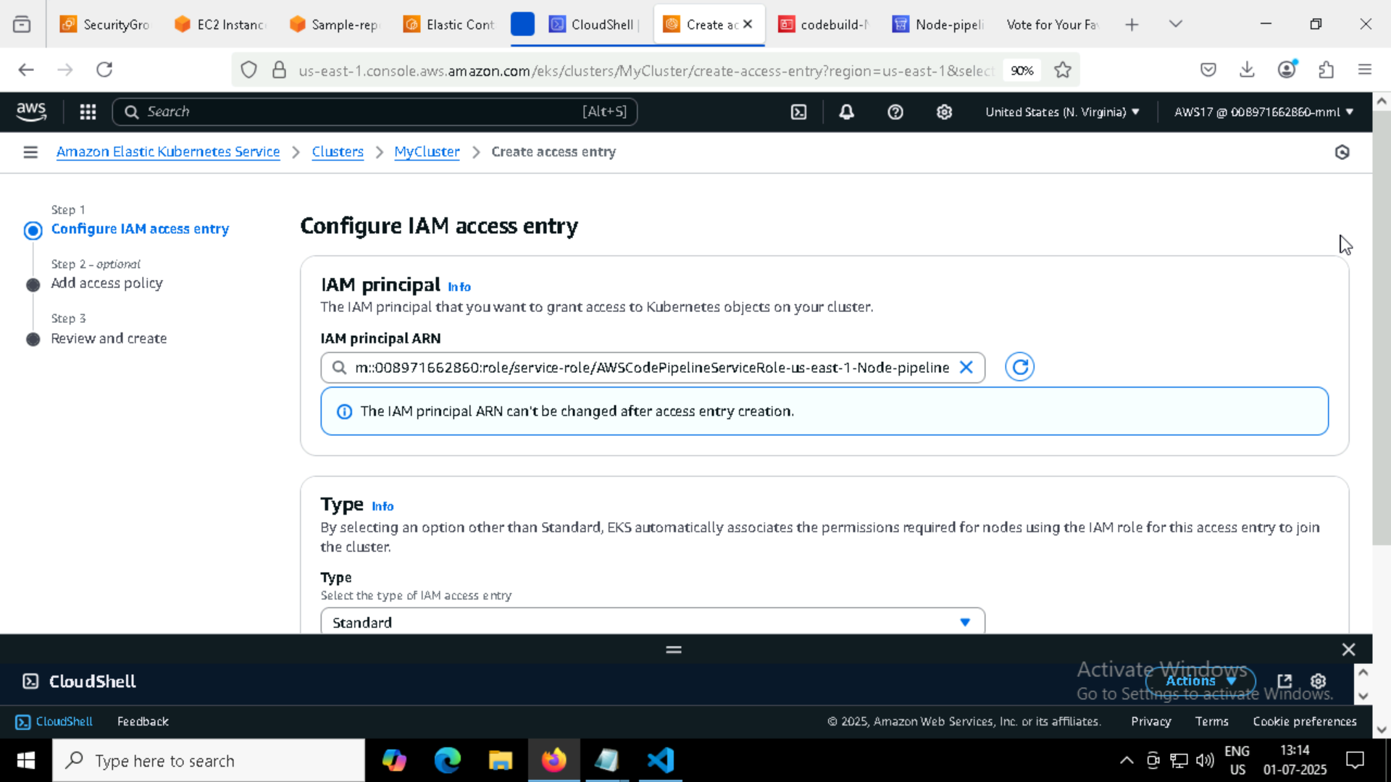

**Giving ClusterAdmin policy to our EKS cluster**

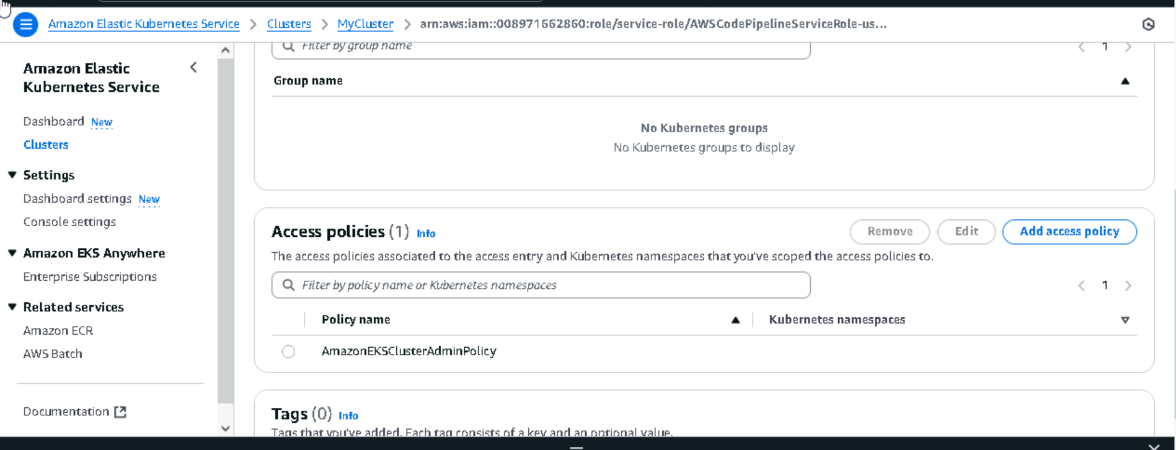

**ECR-EKR Proper integration by Providing Proper IAM Role for Our pipeline**

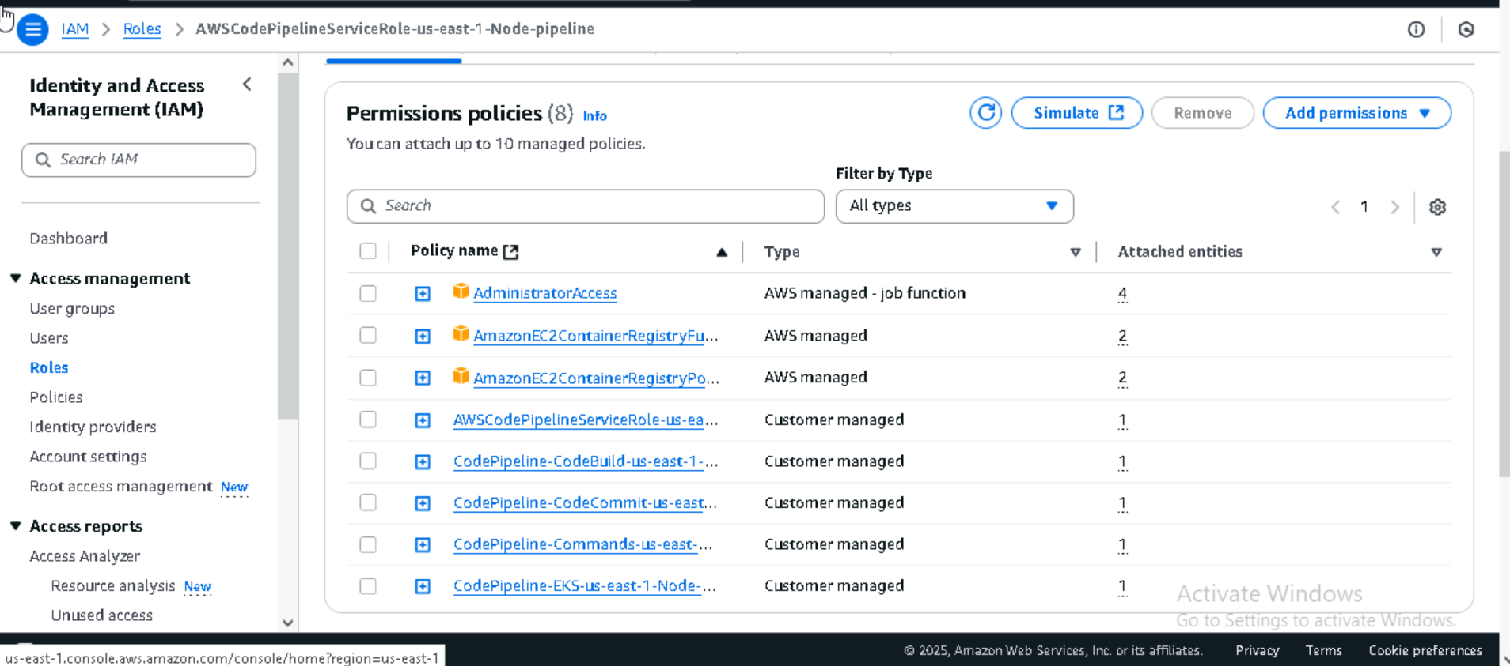

Giving access to EC2 container registry for full access to pull the image from ECR

**Pipeline deployment Succeded**

**Source I used as codecommit and Deployed my application in EKS cluster as you can see in below image**

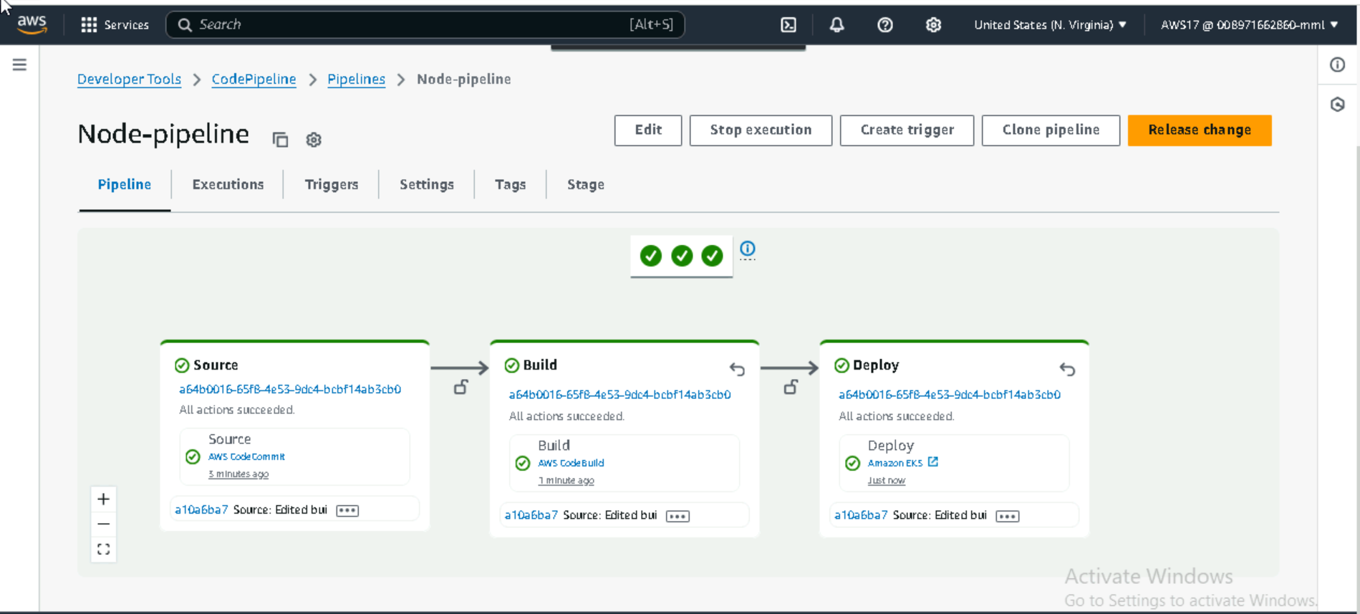

**Pipeline logs**

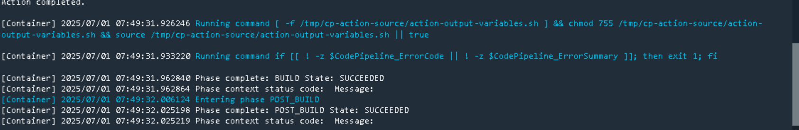

**Checking the Loadbalancer**

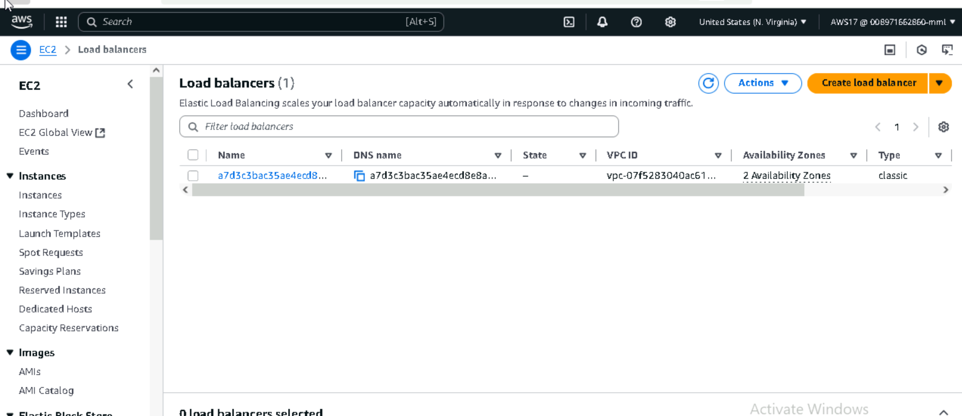

**Now lets Check if our nodejs application is running by accessing loadbalancer dns**

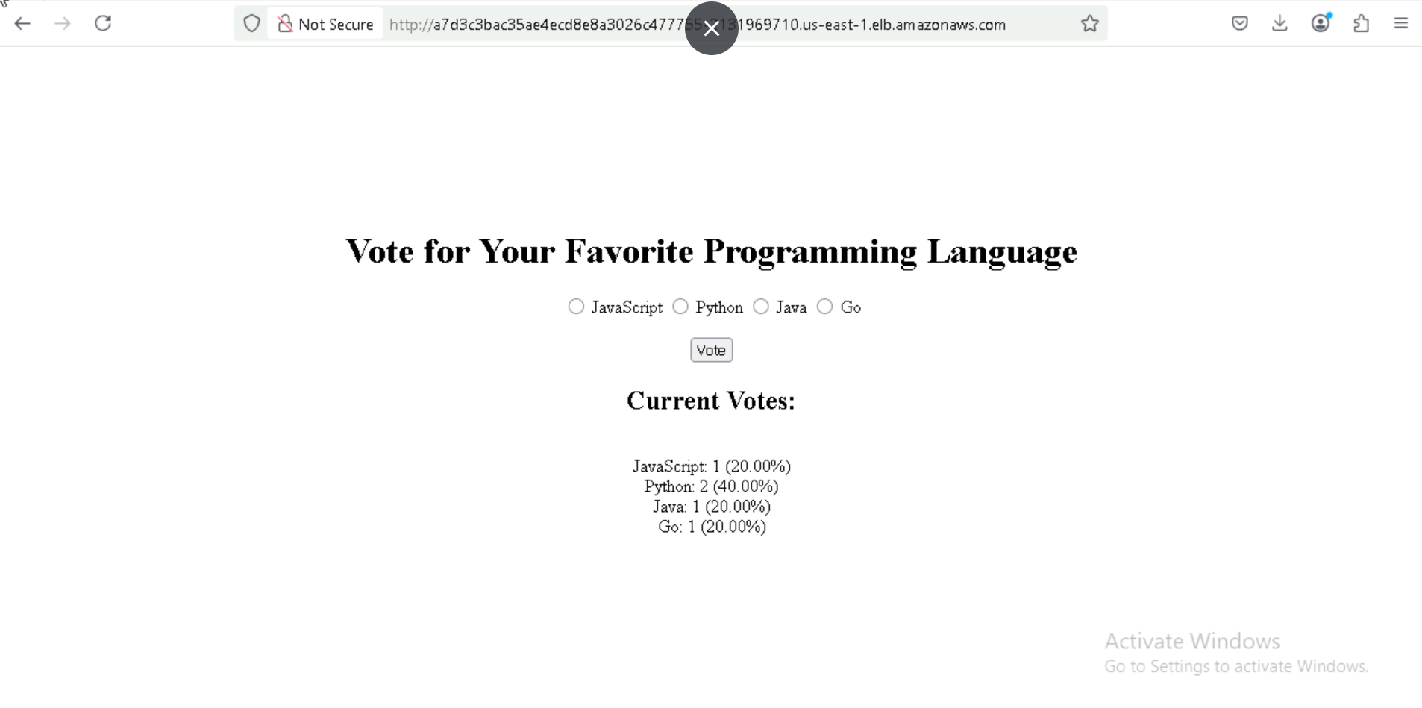

**Now doing manually and verifying if everything is working fine**

**Aws Ecr Login and Docker build :**

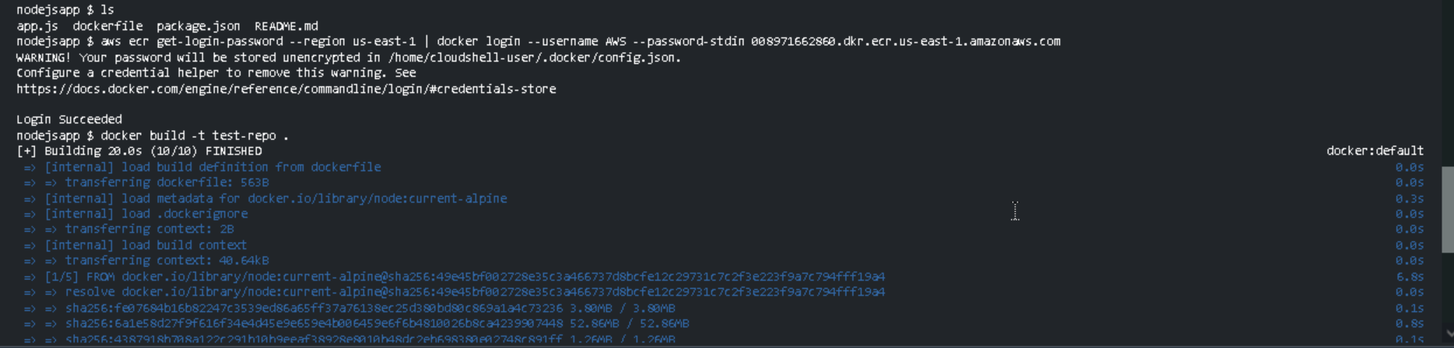

**Tagging and pushing the image**

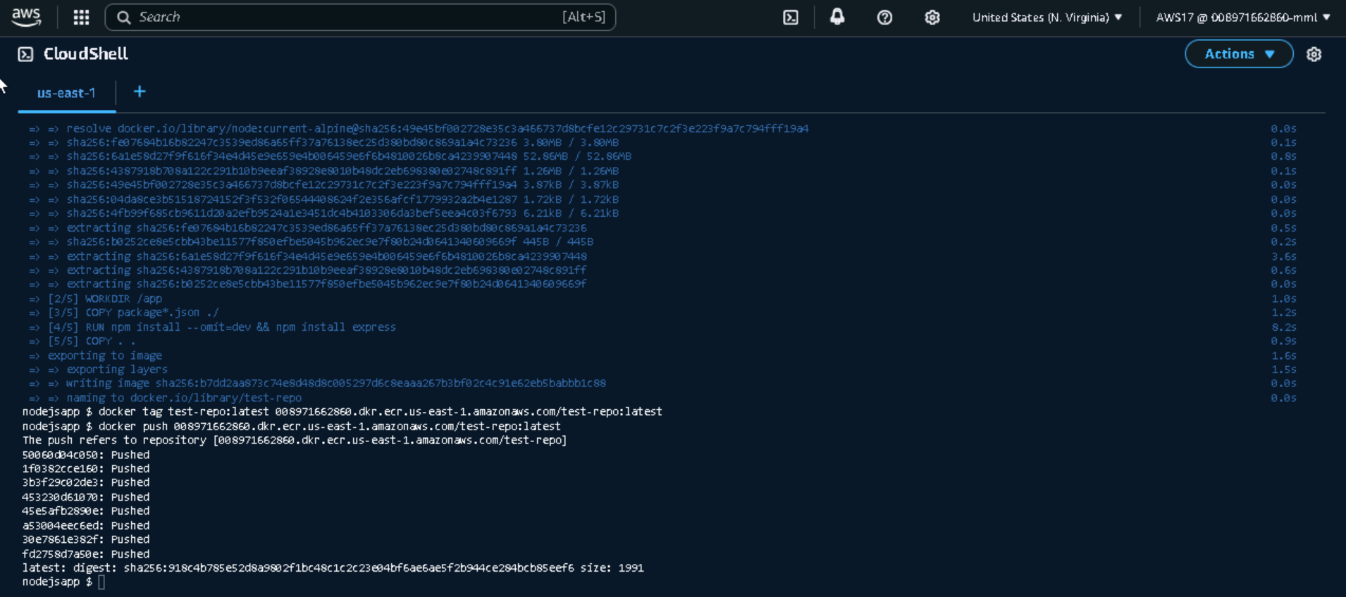

**Creating deployment.yaml and service.yaml then applying both**

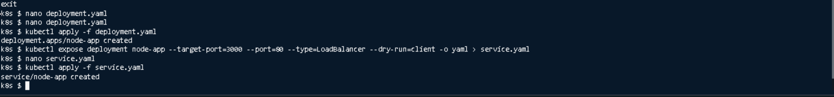

**Deployment.yaml file**

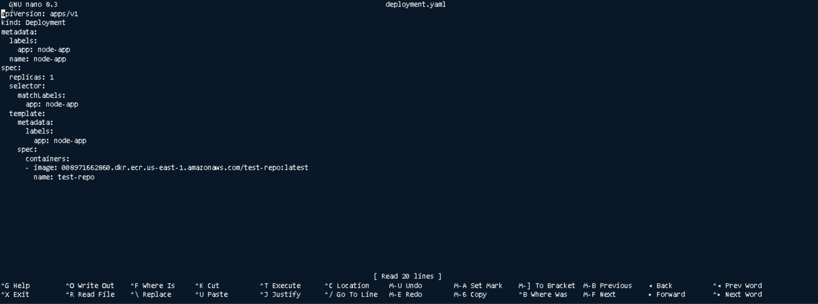

**Service.yaml file**

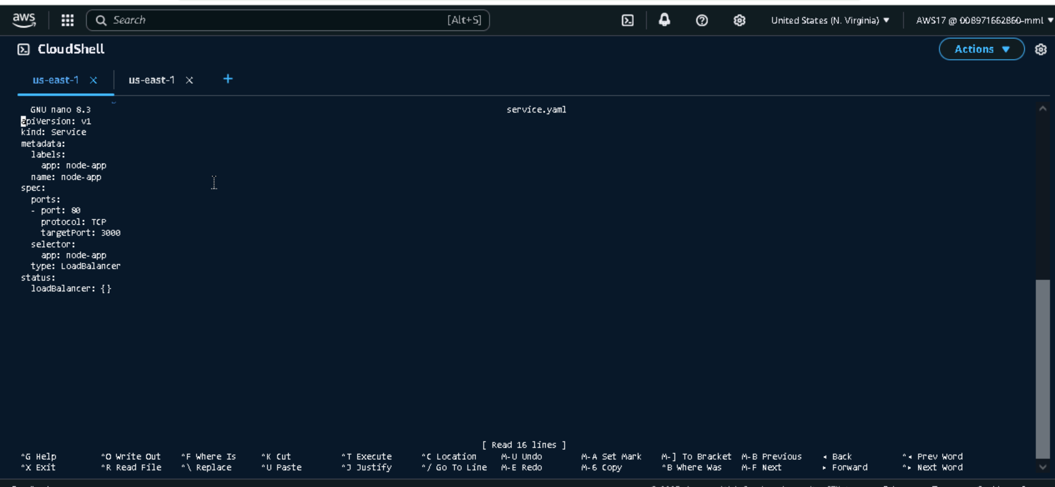

**Verifying the deployment and service yaml files**

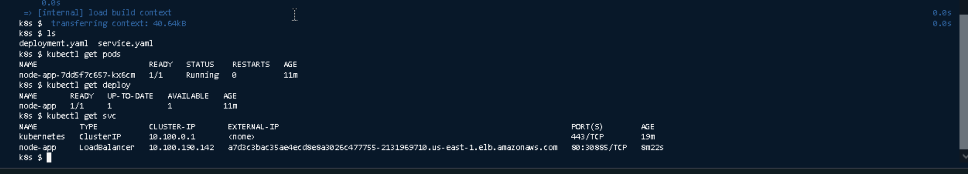

**All my pods are up and in running state and loadbalancer is also created**

**Accessing Loadbalancer through Browser**

**http://<loadbalancer-IP>**

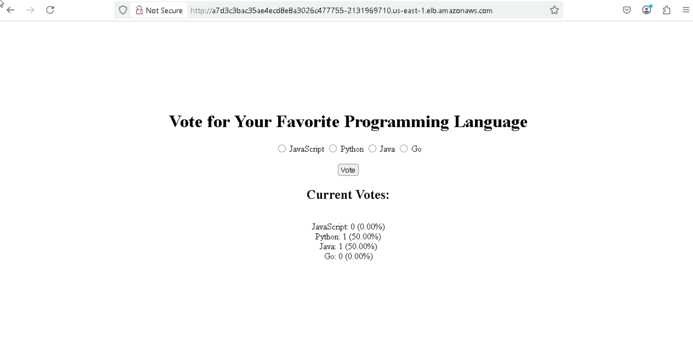

**Application is Up and running successfully**